# *Database Management I (420-D10-HR)*

# *Lab 03 – Introduction to Oracle*

Date assigned: Monday, August 29, 2016

Date due: **Monday, August 29, 2016, 4:50pm**

**Learning Objectives**

Upon successful completion of this lab exercise, the student will be able to:

* 1. sign on to Oracle using Oracle SQL Developer;
  2. populate a database using an SQL script
  3. Introduction of the Select SQL command to perform simple queries. (We will learn more about SQL and it’s overall structure later, for now we will focus only on the ‘SELECT’ command).

**To uploaded Moodle:**

1. Fill in this document with your answers, rename to ***username_*D10_L03_Oracle.doc** and upload to Moodle.

**Marks:**

|  |  |  |
| --- | --- | --- |
| **Question** | **Mark** | **Out of** |
|  |  |  |
| Part C – Manual browsing 16 questions |  | 16 |
| Part D – SQL queries and results |  | 16 |
| Organization |  | 3 |
| **Total** |  | **35** |

Note: Part A, B, C will be demonstrated by your professor. Optionally, you can find similar demonstration videos on youtube on the [basics of using Oracle SQL Developer](https://www.youtube.com/watch?v=TrrM9HCLJn8).

# Logging onto Oracle

***Objectives***: Learn to log on to Oracle using SQL Developer.

Note: you can install SQL developer locally on your personal machines to connect into the Oracle server. SQL Developer is a thin client providing an interface into the Oracle server where most of the heavy lifting is done.

***To Do:***

## Start **SQL Developer**.

## Select **File 🡪 New 🡪 Database Connection**

## Complete the window as follows:

### **Connection Name**: Anything you want - e.g. your username

### **Username**: Your short username (i.e. rchan)

### **Password**: same as your username

### **Role**: default

### **Connection Type**: basic

### **Hostname**: csoracle.cegep-heritage.qc.ca

### **Port**: 1521

### **SID**: xe

## Click **Connect**. A window will open with your connection name in the tab.

# Run an SQL Script

***Objectives***: Run an SQL script to create a sample database.

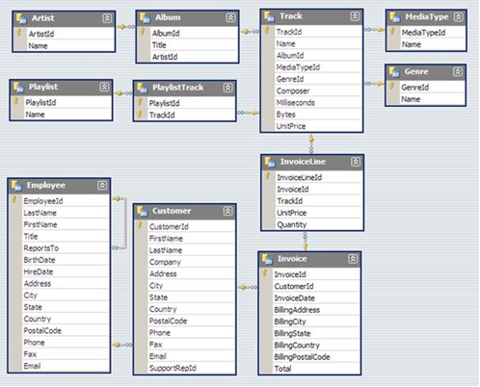

***Chinook database,. Step by step commands on how to run this will be demonstrated for you.***

# Browsing and Navigating within SQL Developer

***Objectives***: Learn how to browse a database using SQL Developer.

Note that there is a Connections window shows you all your sessions with the Oracle servers.

You can browse the database using this window.

Class follow-along exercise.

Look for your session on the left. (You can have several sessions open simultaneously to different databases. For now, you just have one).

Expand the “Tables”

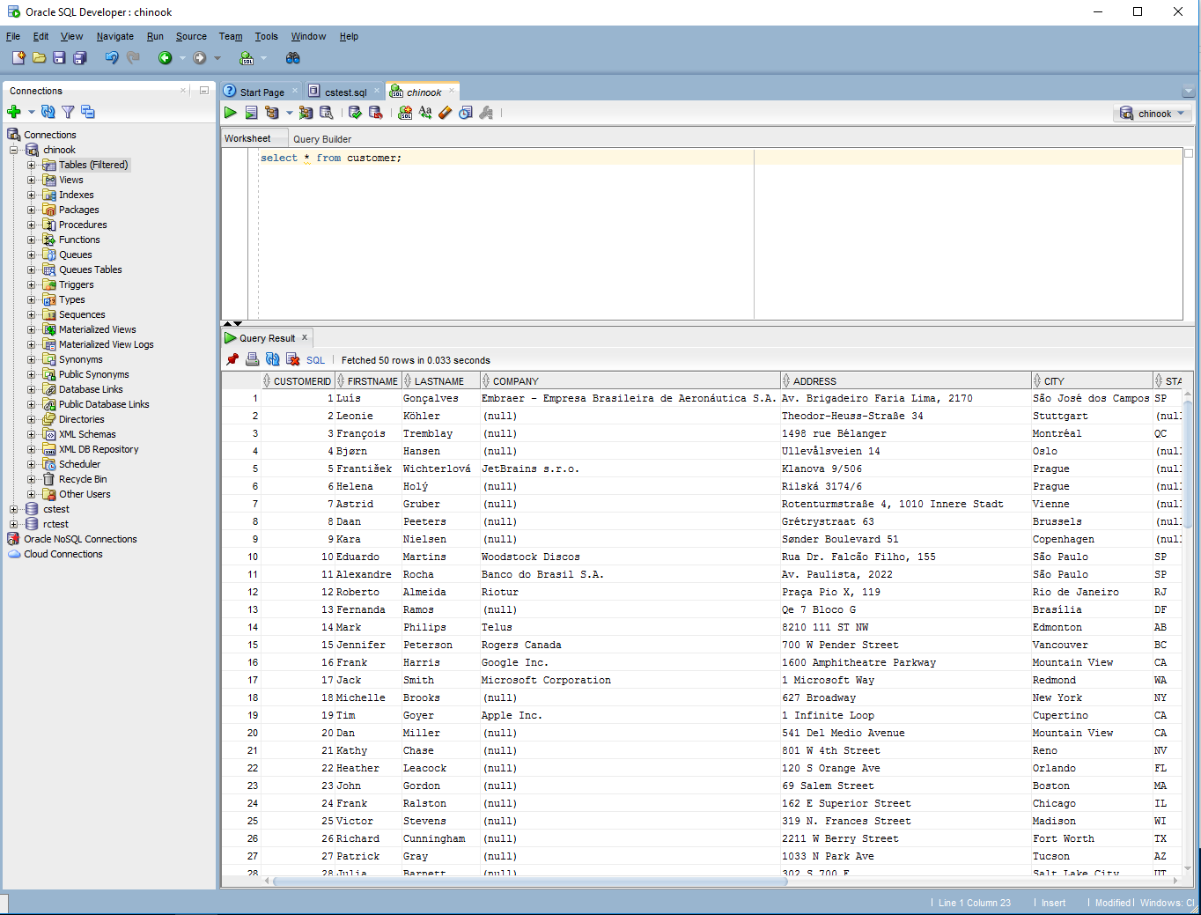

Note that the Tables contained in the database are now shown.

You can select a table to see details on a table.

Click on the Customer table to see details on the CUSTOMER table.

Note that a new tab opens up on the right window frame showing you details of the CUSTOMER table.

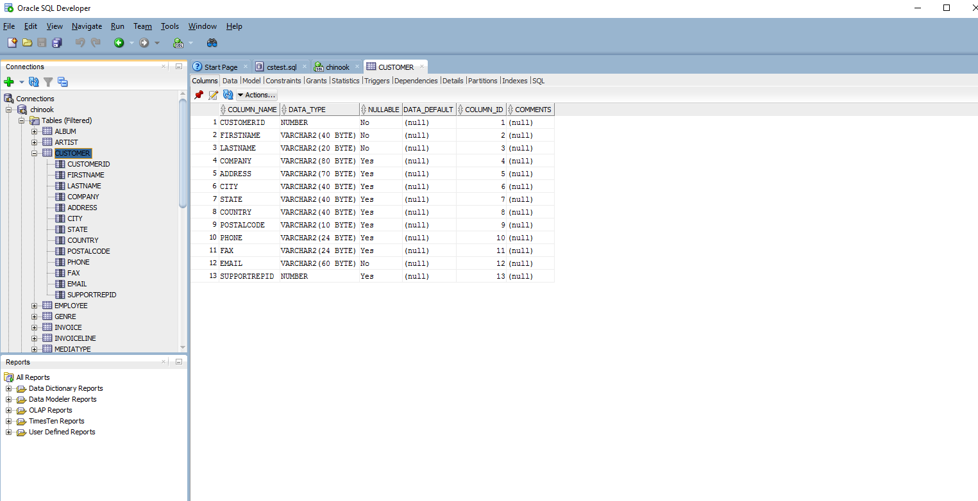

Note also that there are multiple sub-tabs within the new CUSTOMER frame.

For now experiment with the “Columns” and the “Data” sub-tabs to see what the columns of the Customer table are, and what the raw data contained is.

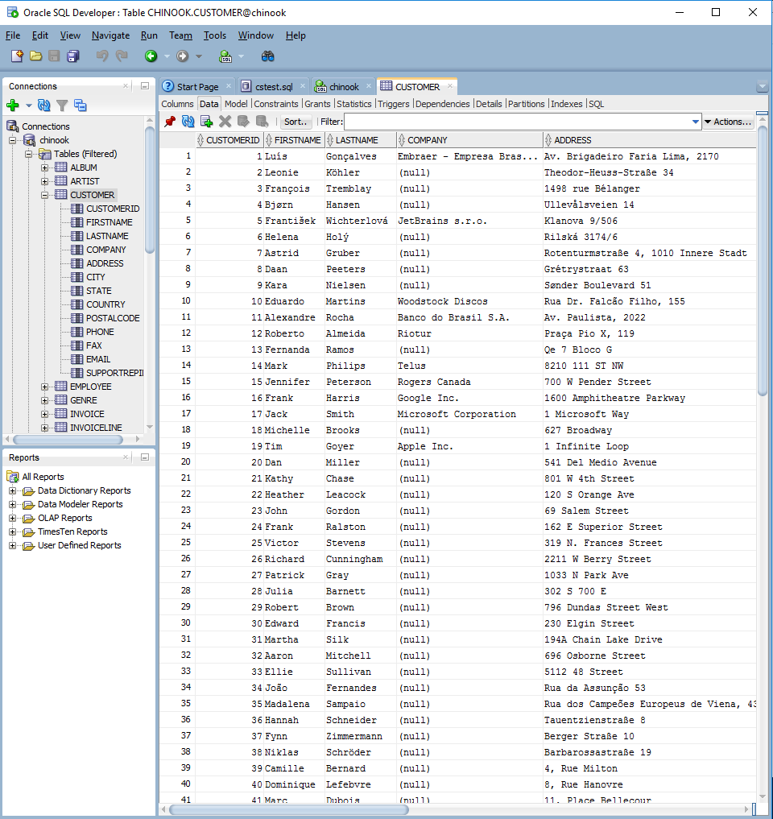

Note that the column headers of the data allow you to sort and filter. (Hint: This will come in handy later in this lab).

Browse the database and complete the following table:

|  |  |
| --- | --- |
| Question | Answer |
| What tables are part of the Chinook database? | * ALBUM * ARTIST * CUSTOMER * EMPLOYEE * GENRE * INVOICE * INVOICELINE * MEDIATYPE * PLAYLIST * PLAYLISTTRACK * TRACK |
| What fields are in the Employee table? | EMPLOYEEID  LASTNAME  FIRSTNAME  TITLE  REPORTSTO  BIRTHDATE  HIREDATE  ADDRESS  CITY  STATE  COUNTRY  POSTALCODE  PHONE  FAX  EMAIL |
| What datatype of field is the Employee phone number? What is the maximum length (in characters) of the Employee phone number? | Datatype: VARCHAR2  Length: 24 characters |
| How many Employee records are there in the database? | 8 |
| What is the name of EmployeeId 5? | Steve Johnson |
| Who is the manager of Laura Callahan | Michael Mitchell |
| Who reports to Nancy Edwards | Jane Peacock  Margaret Park  Steve Johnson |
| The company sells meda (video/audio) online. How many Genre categories are there? | 25 |
| Pick your favourite genre. What is it and what is the corresponding GenreId? | Genreid: 1  Name: Rock |
| How many different Artists are in the database? | 275 |
| Who is the artist with artistID = 167 | Big & Rich |
| What is the name of the Artist for the album American Idiot. Explain how you figured this out using the table names, fields and values. | Green Day.  Filter the album table to the title American Idiot, then find the artist ID. Then find the artist with the corresponding Id in the artist table. |
| What is the name of the 11th track on the album American Idiot? Explain how you figured this out using the table names, fields and values. | Letterbomb  Filter the album table to American Idiot. Find the album Id. Go to the Track table and filter the album it to that of Green day. Find the 11th track. |
| What albums by Queen are in the database? Explain how you figured this out using the table names, fields and values. (Do this for the rest of the questions) | Greatest Hits II  Greatest Hits I  News Of The World  Find the artist ID for Queen. Filter the album table to albums with that album ID. |
| What is the 17th track of Queen’s “Greatest Hits I” | We Are The Champions  Filter the album table to the “Greatest Hits I” album. Find the album’s ID. Filter the track table to that |
| What album is the song called “Cucamonga” from? Who are the artist on that album? |  |

# Queries I

***Objectives***: Learn the Select command to answer simple queries.

Research: W3Schools [Select](http://www.w3schools.com/sql/sql_select.asp) page. Learn Select, Where, Distinct, Like, order by

All queries start with the CUSTOMER table. Provide the SQL query and the output.

Let’s make sure that you’ve setup everything properly for future logins.

Exit from Oracle SQL Developer.

Restart Oracle SQL Developer, login as yourself and ensure that you can still browse the tables in the database.

**Teacher will demonstrate how to run SQL commands in lab session.**

Reference: <http://www.oracle.com/technetwork/developer-tools/sql-developer/query-intro-1-161240.html#intro> shows the basics on how to run SQL statements in Oracle SQL Developer.

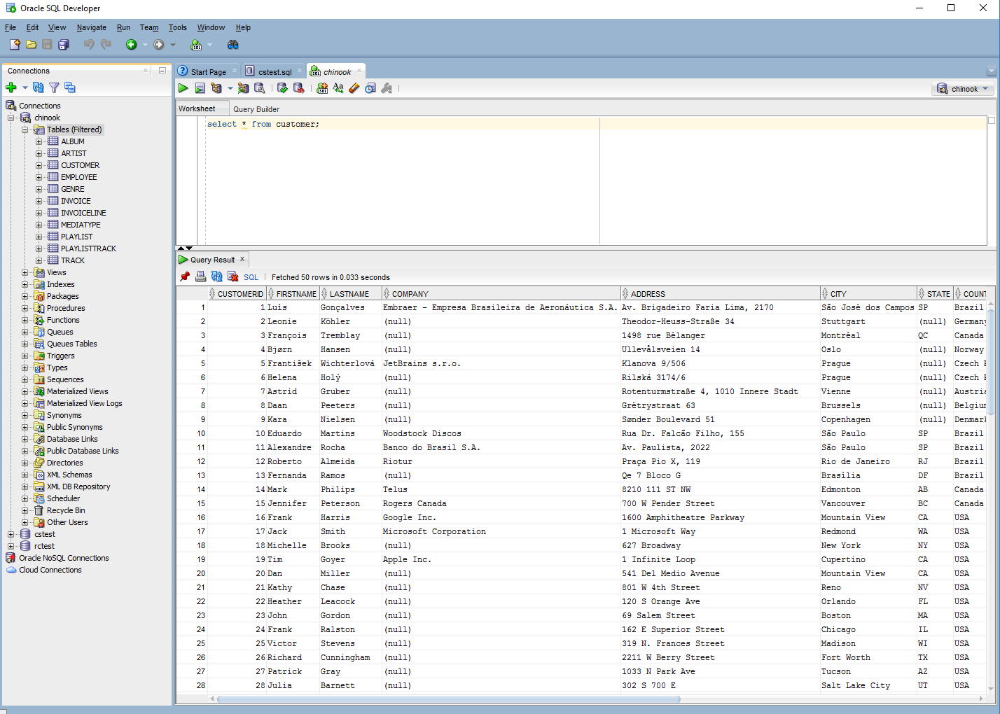

Perform the following queries:

|  |  |  |
| --- | --- | --- |
| Question | SQL Answer | Paste SQL output |
| List all customers |  |  |
| List all customers whose address is in CANADA |  |  |
| List all customers whose address is in Quebec |  |  |
| List all customers who is not in USA. |  |  |
| Show only the first and last name, and email of all customers |  |  |
| Show all distinct cities that the customers are in. How many unique cities are your customers in? |  |  |
| Show only the first and last name of all customers with a gmail address |  |  |
| List all customers that have provided a Company, sorted by company name |  |  |